Is Publishing in Your Midst?

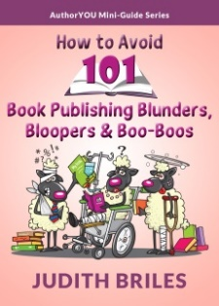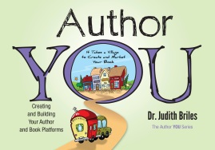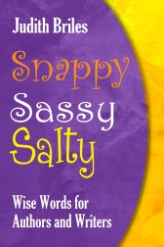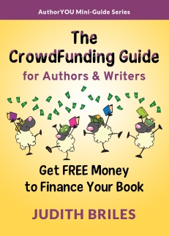
Judith Briles, The Book Shepherd
- Why Write? Why Publish?
- What’s your topic?

- Who are you creating a book for?

- What is the power of a niche book?
- What are your publishing options today?

- What’s the cost of publishing?

- What is Crowdfunding and does it work for books?

- What are you willing to invest?
- Do you have a Platform?
Vision
Passion
Commitment
People
- What’s a GamePlan and do you have one?

- Who do you need on your publishing team?

- Publishing Predators … what do they look like and how do you avoid?

Money Talks … Are You Listening?

Part of being an author, and publisher, is to understand the numbers. They speak … and loudly at that. Comparing the three scenarios below, you get:

Summing Up …

Net Royalties vs. Wholesalers vs. Solo Selling

Trade Paper $15 Hardback $25
# of  Books Sold | 1,000 | 3,000 | 5,000 | 10,000 | 1,000 | 3,000 | 5,000 | 10,000
#1 Traditional  Royalties | $470 to  $610 | $1,410 to $1,830 | $2,350 to $3,050 | $4,700 to  $6,100 | $1,130 | $3,390 | $5,650 | $ 12,700
#2  Wholesalers-  Distributors | $2,691 | $8,639 | $20,017 | $48,390 | $ 599 | $19,109 | $37,615 | $85,218
#3  Publishing  Independent | $5,559 | $33,389 | $61,267 | $130,890 | $14,349 | $60,359 | $106,365 | $222,718

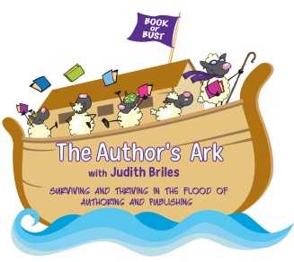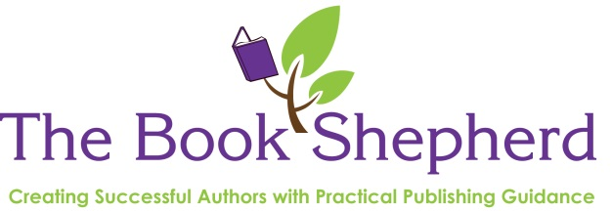
Judith@Briles.com | 303-885-2207

